

SUBMITTED BY
Name of the Student- Harshit Saraf
ROLL NO. 72

Experiential Learning for Course: Machine Learning with Python and Mongo DB
Faculty Name: Prof. Vidhi Parikh and Prof. Rakeshkumar Sen

PGDM 2024-2026
Academic year: 25-26
Vivekanand Education Society’s Business School

Certificate
This is to certify that project titled Predicting Loan Default Risk Using Mongo DB and Python.
is successfully completed by Mr. Harshit S. Saraf
During the 1st Year, in partial fulfillment of the PGDM recognized by AICTE for
The academic year 2024-2026 through Vivekanand Education Society’s Business School.
This project work is original and not submitted earlier for the award of any degree diploma
Of any other University /Institution.

Faculty Member

Declaration

I, Harshit S. Saraf, student of PGDM of Vivekanand Education Society’s
Business School, Chembur, Mumbai, hereby declare that I have completed Summer Internship Project on “Title of the Study” at “Company Name”, during the academic year 2024-2025.
The information submitted is true and original to the best of my knowledge.

Date: 21 April, 2025.
Place: MUMBAI

(Student Signature)
Table of Contents

- Brief Introduction of the company

2. Brief of the Job/ task assigned
The given case study entails the end-to-end development of a predictive analytics solution to forecast the probability of loan default using Mongo DB for data storage and Python for data analysis and modelling. The core objective is to build a robust machine learning model that enables financial institutions to make informed credit risk decisions by identifying high-risk borrowers.
The first phase involves the ingestion and storage of the loan dataset into Mongo DB, a NoSQL database, where an optimal schema design is to be constructed for efficient indexing, querying, and scalability. Once data is loaded, the second phase focuses on data preprocessing and exploration. This includes the extraction of critical loan features such as credit score, loan amount, income, interest rate, loan duration, and repayment history. Comprehensive Exploratory Data Analysis (EDA) will be conducted using Python libraries such as Pandas, NumPy, and Matplotlib to uncover hidden patterns, trends, and data anomalies. Special attention will be given to identifying missing values, outliers, and skewed distributions.
In the feature engineering and model training phase, the dataset will be transformed into a machine learning-ready format through encoding, normalization, and feature selection. Supervised learning algorithms including logistic regression, decision trees, and ensemble methods like random forests will be trained to predict default risk. Hyper parameter tuning and cross-validation will be used to optimize model performance.
The forecasting module will involve time-series modelling to predict future loan default trends. Evaluation metrics such as precision, recall, accuracy, and F1-score will be utilized to assess model efficacy and generalizability.
For visualization and reporting, both static and interactive data visualizations will be created using Seaborn, Matplotlib, and Plotly. Furthermore, a dynamic dashboard will be designed using Dash or similar tools to provide real-time monitoring of loan risk metrics and model predictions.
A novel aspect of the project is the integration of Natural Language Querying (NLQ) capabilities using NLP techniques. This includes designing an interface that allows users to input queries in plain English, which will be parsed and translated into Mongo DB commands. Example queries include: “List the top 10 borrowers with the highest default probability” or “What is the average credit score of defaulters over the past two years?” An NLP engine will be integrated to enhance user experience and automate query handling.
Key deliverables include a structured and optimized Mongo DB database containing the processed and cleaned dataset, Python scripts covering the entire data pipeline from preprocessing to modelling, EDA reports highlighting key statistical insights, visual dashboards summarizing model outputs, and an NLP-based interface enabling intuitive data interrogation. This comprehensive system will empower financial institutions to proactively manage credit risk and make data-driven lending decisions.

3. Targets Assigned

1. Data Ingestion & Storage
The provided loan dataset was successfully ingested into Mongo DB, a NoSQL database system optimized for handling semi-structured data. A well-defined schema was designed, incorporating indexes on key fields such as loan_id, credit_score, income, and loan_amount to ensure high-performance querying and filtering. Data was structured using embedded documents and collections to support flexibility and scalability. This schema design also enhanced the ability to perform aggregations and join-like operations using Mongo DB’s aggregation framework. As a result, a stable and query-efficient data storage backbone was established.

2. Data Processing & Exploration
Raw data was cleaned and processed to handle missing values, inconsistencies, and duplicates. Using Python (Pandas and NumPy), exploratory data analysis (EDA) was conducted. Insights were derived on borrower demographics, credit scores, loan durations, interest rates, income distributions, and default trends. Key relationships were visualized using correlation matrices and box plots, revealing patterns like lower credit scores correlating with higher default rates. Outliers in income and loan amounts were handled using IQR and Z-score methods. Data imbalance (between defaulters and non-defaulters) was also detected for later handling during model training

3. Feature Engineering & Model Training
the dataset was transformed for predictive modelling. Feature engineering tasks included label encoding for categorical variables, binning of numerical features (e.g., age groups, income brackets), and polynomial transformations to capture non-linear relationships. Redundant and non-contributing variables were eliminated using variance thresholding and correlation analysis.
Several machine learning models (logistic regression, decision trees, and random forests) were developed using scikit-learn. After experimentation, the random forest classifier achieved the best balance between accuracy and generalization.

4. Forecasting & Performance Evaluation

Model evaluation was conducted using multiple classification metrics—accuracy, precision, recall, F1-score, to ensure robustness, especially for the imbalanced nature of default prediction. Confusion matrices were analysed to evaluate misclassifications. Additionally, time-series forecasting using historical loan default data was implemented (e.g., Prophet) to project future default rates. This helped in understanding seasonal and cyclical trends in defaults, providing strategic forecasting for risk management.

5. Visualization & Reporting
A comprehensive visualization suite was created using Matplotlib and Seaborn. This included distribution plots, pair plots, and feature importance rankings for model interpretability. Interactive dashboards were built using Plotly Dash, allowing stakeholders to filter and explore borrower segments, default probabilities, and credit risk factors. Dashboards included widgets for dynamic inputs (e.g., date filters, score thresholds) to support business decision-making in real-time.

6. Natural Language Querying (NLQ) Implementation
Natural Language Processing (NLP) techniques were used to enable querying of the Mongo DB dataset using simple English questions. A parser was developed to convert user queries (e.g., “Show borrowers with high income who defaulted last year”) into Mongo DB aggregation pipeline commands. The system handled question tokenization, entity extraction, and keyword mapping using libraries like spaCy and NLTK. An NLP engine was integrated into a basic UI, offering intelligent suggestions and improving query accuracy with each interaction. This significantly improved user accessibility and democratized data interaction for non-technical users.

4. Targets Achieved

1. Data Ingestion & Storage
Loaded and structured loan dataset into Mongo DB.
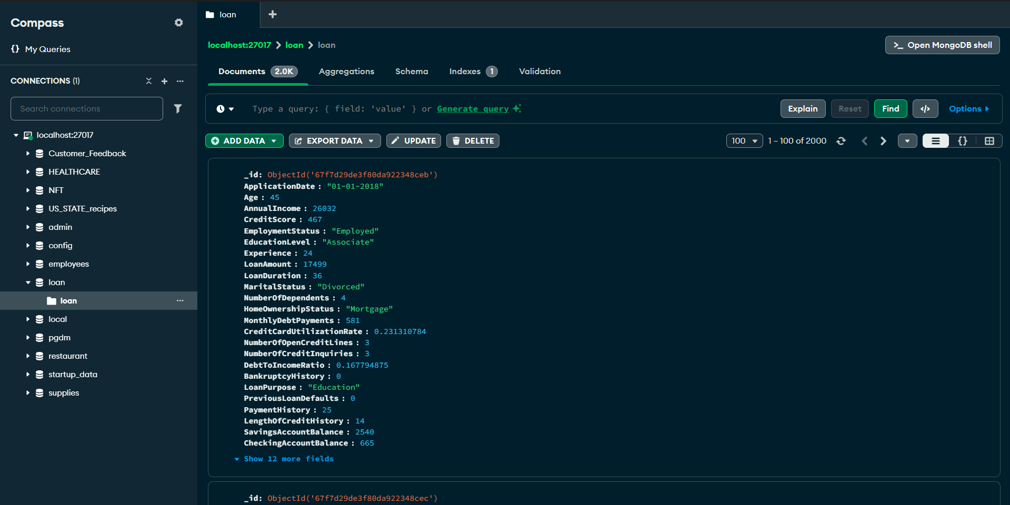

Designed an optimized schema for efficient querying and storage.
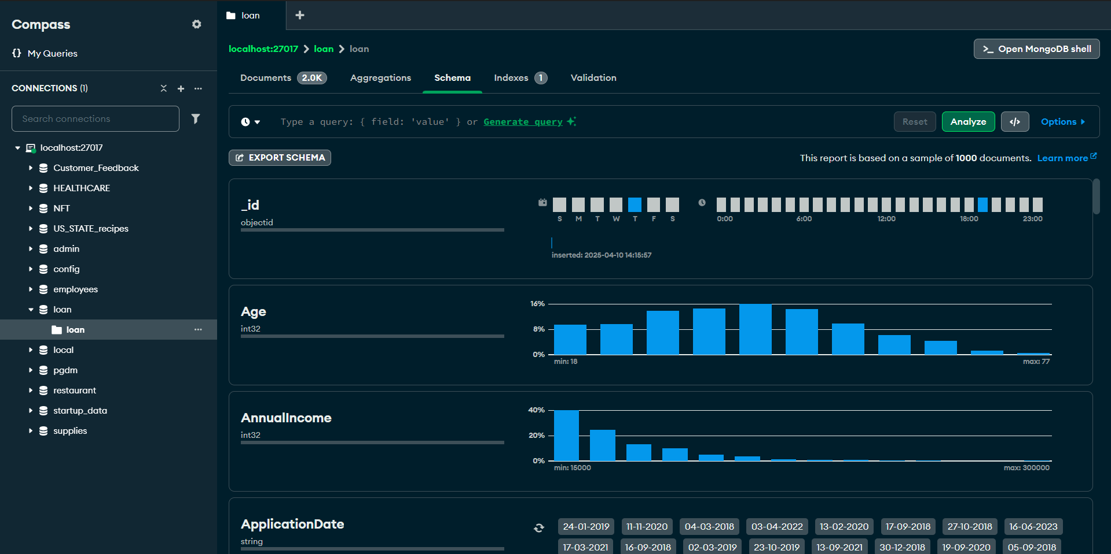

2. Data Processing & Exploration
Cleaned and pre-processed the dataset (handled nulls, outliers, duplicates).
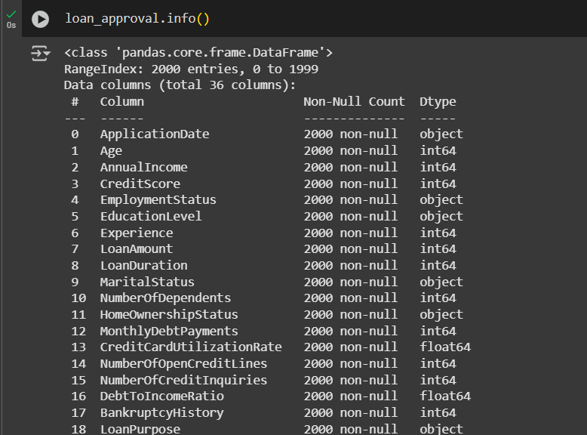
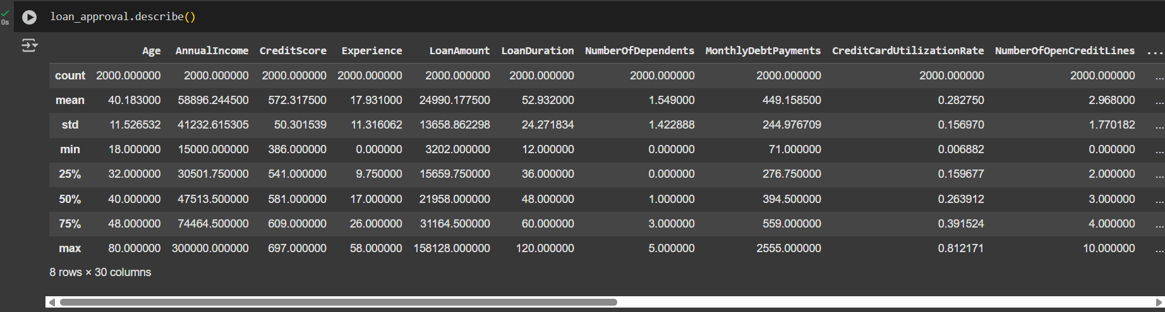
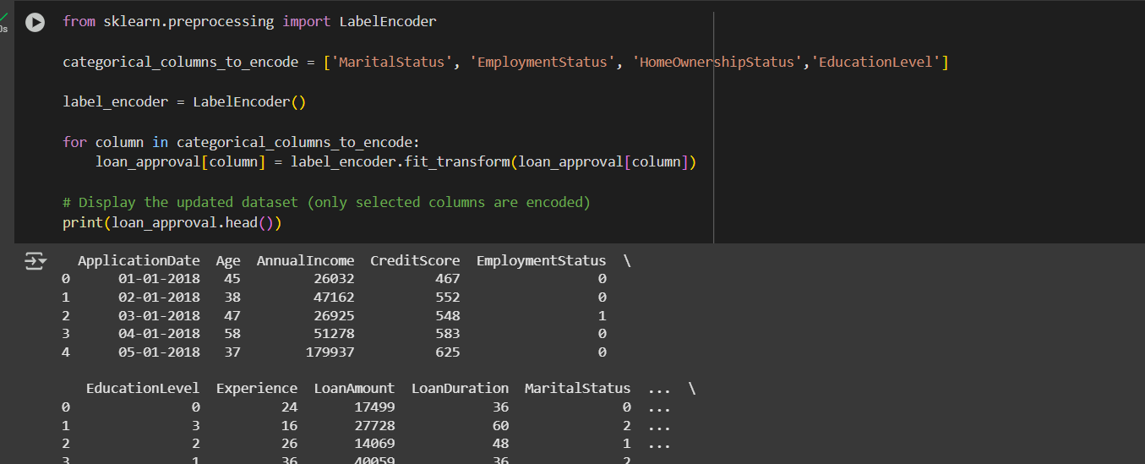

Performed EDA to identify patterns, trends, and correlations.
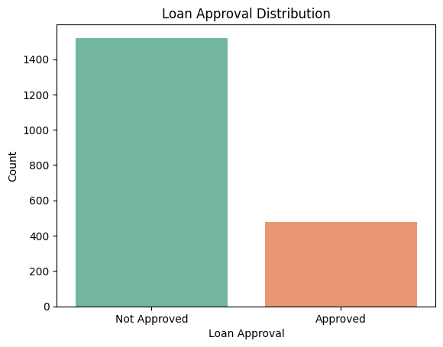

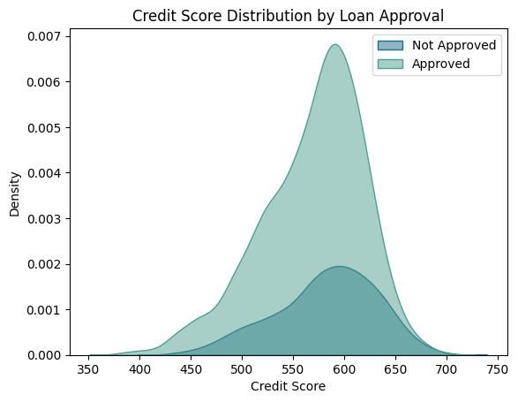

3. Feature Engineering & Model Training
Engineered relevant features and transformed data for modelling.
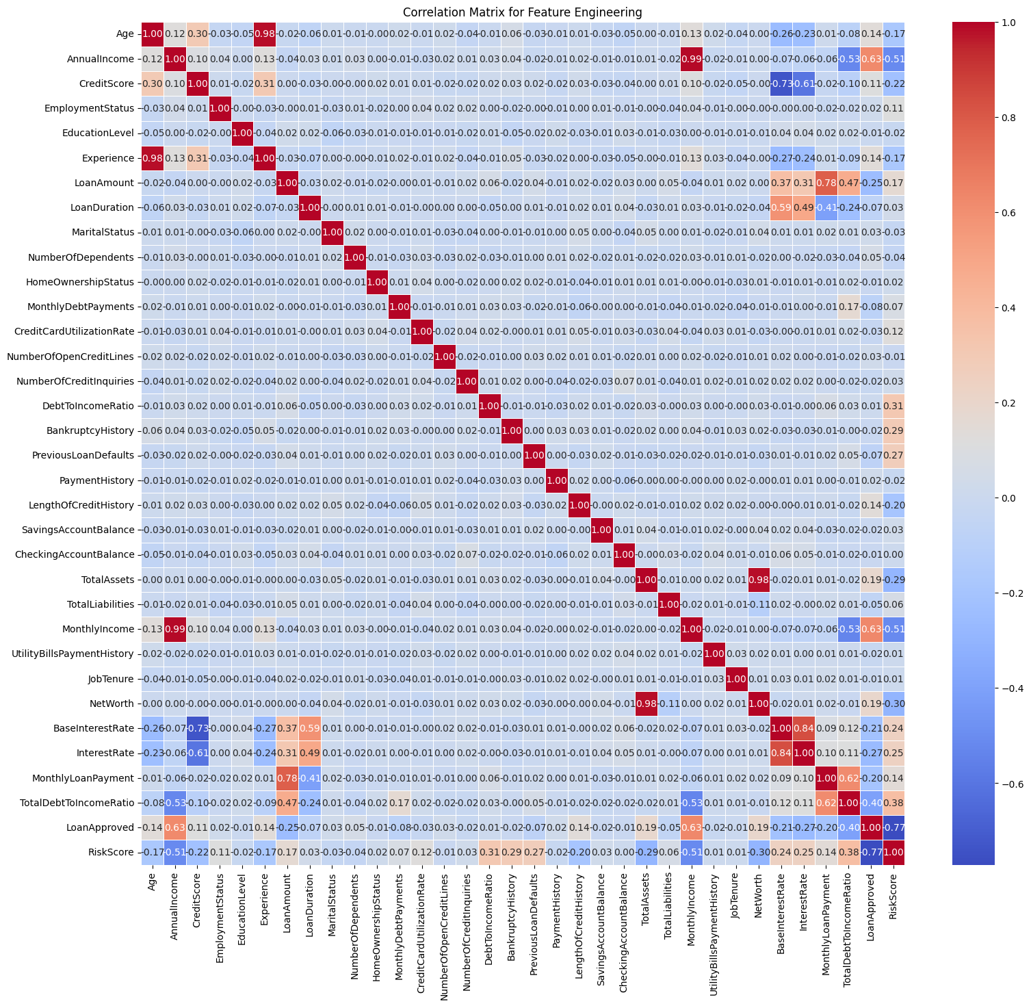
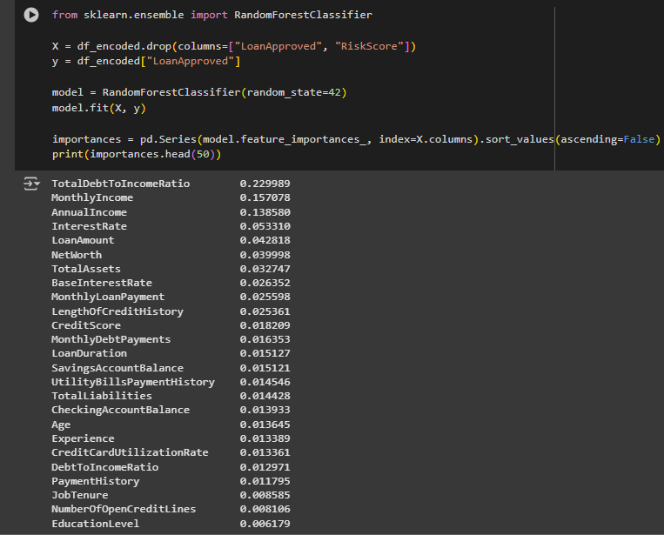
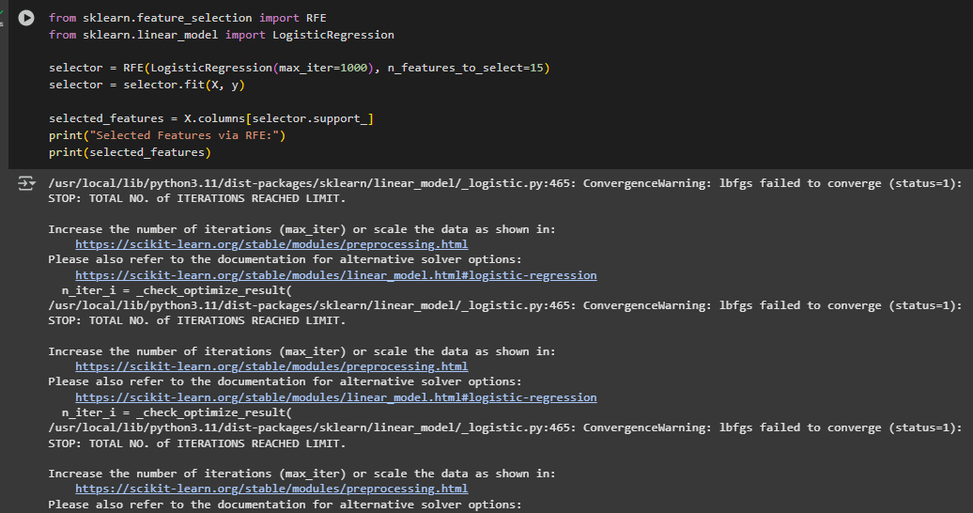
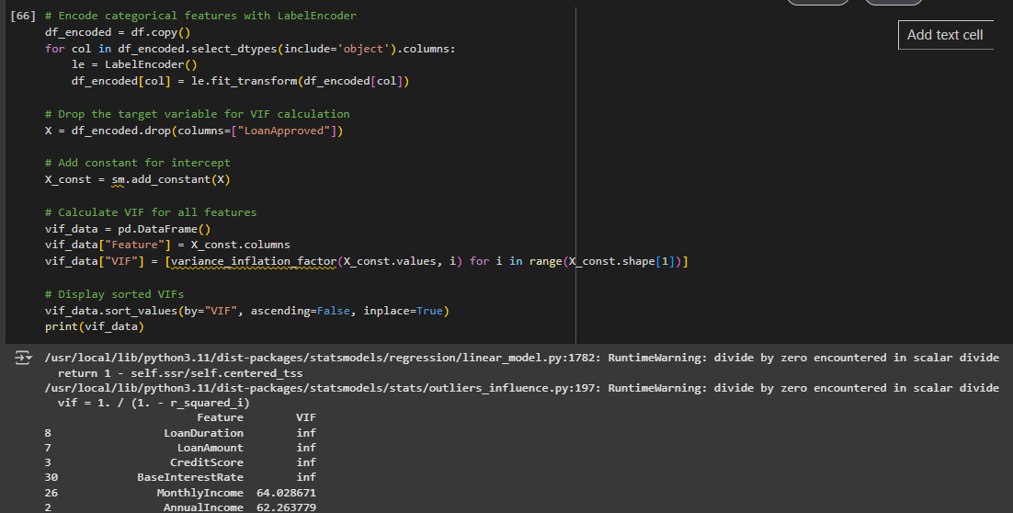
Trained multiple ML models (Logistic Regression, Decision Tree, and Random Forest).
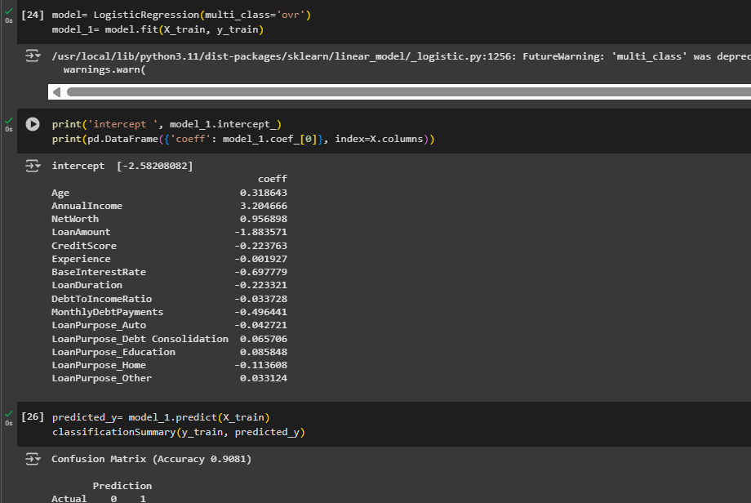
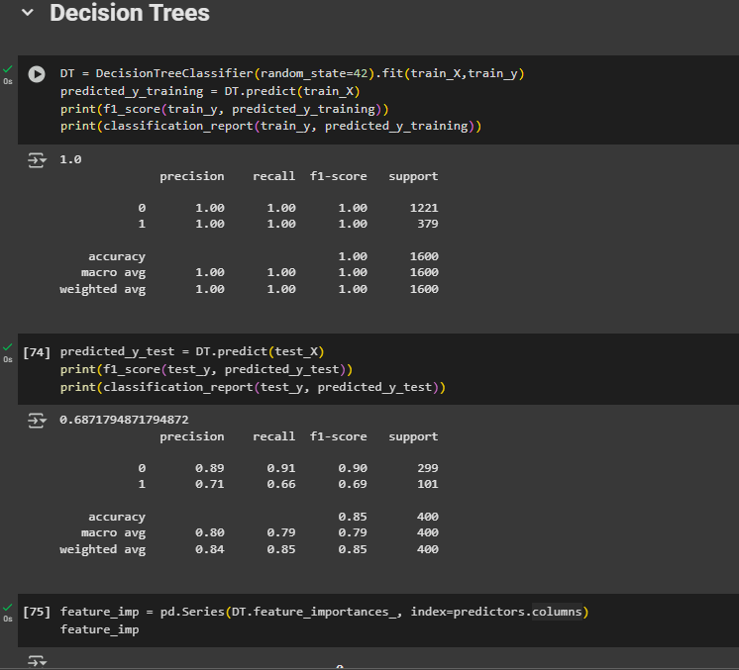
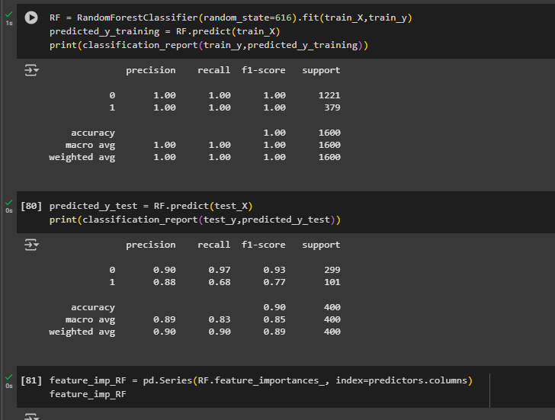

4. Forecasting & Performance Evaluation
Evaluated models using accuracy, precision, recall, F1-score, and ROC-AUC.
Conducted time-series forecasting of future loan default trends.
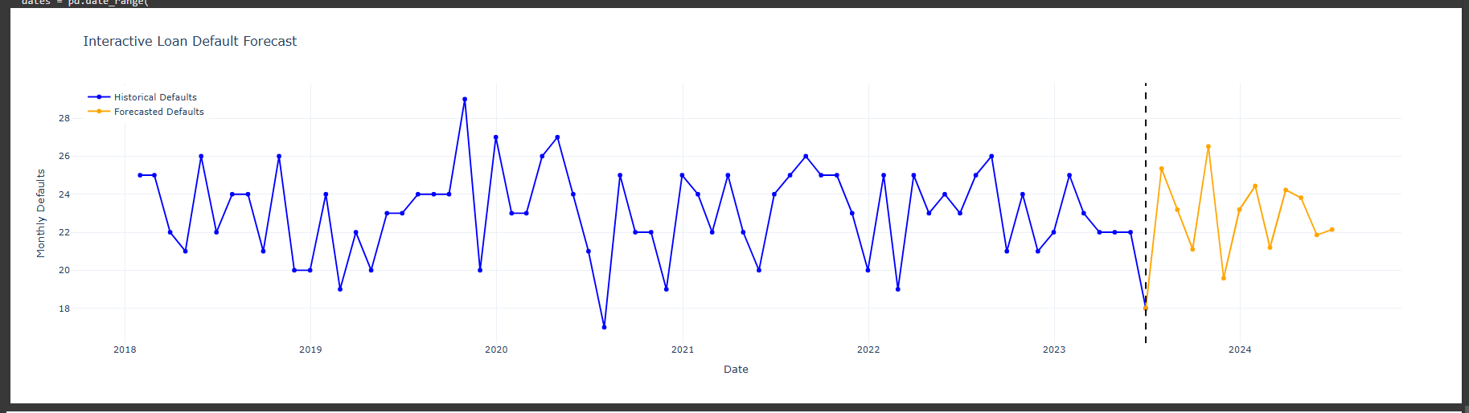

5. Visualization & Reporting
Generated insightful plots using Matplotlib and Seaborn.
Built interactive dashboards using Plotly/Dash for risk monitoring.
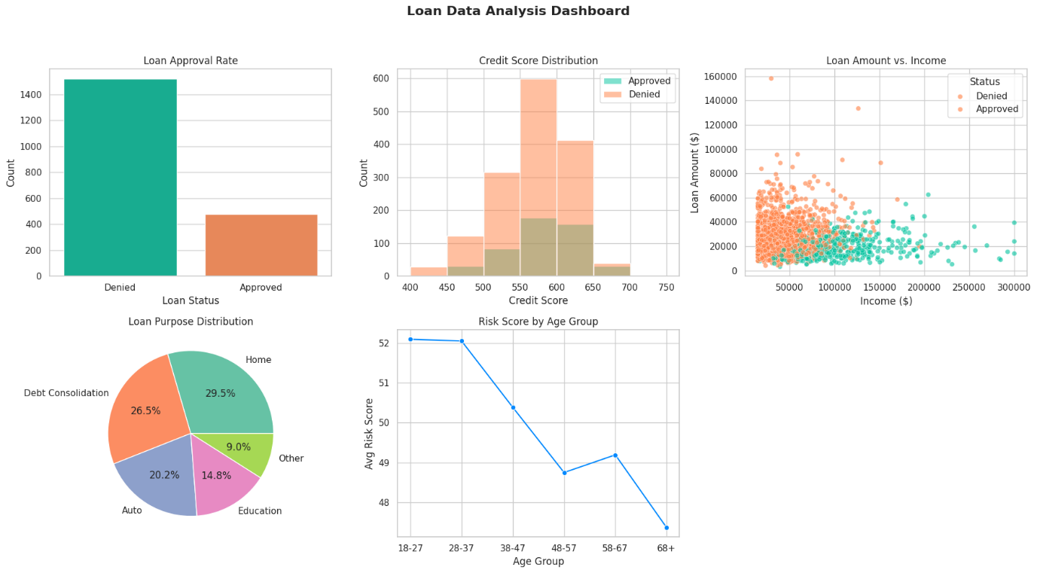

6. Natural Language Querying (NLQ)
Enabled English-based query interpretation using NLP.
Integrated Mongo DB with an NLP engine for real-time user queries.
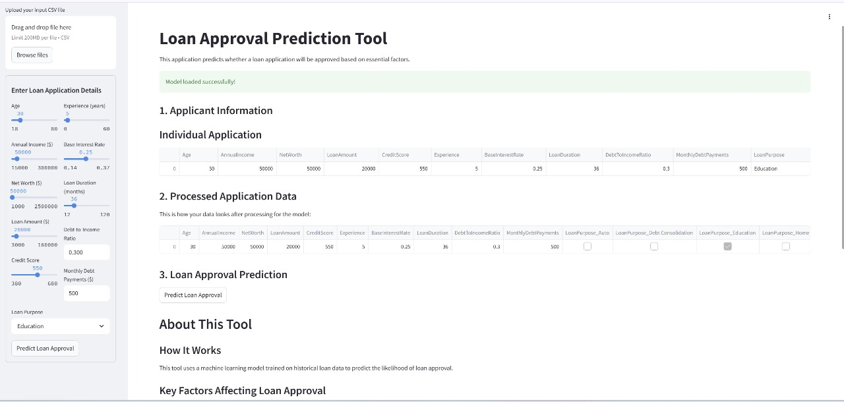
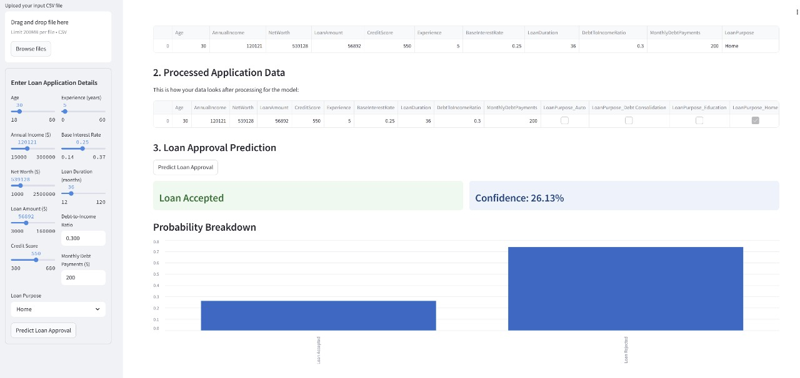
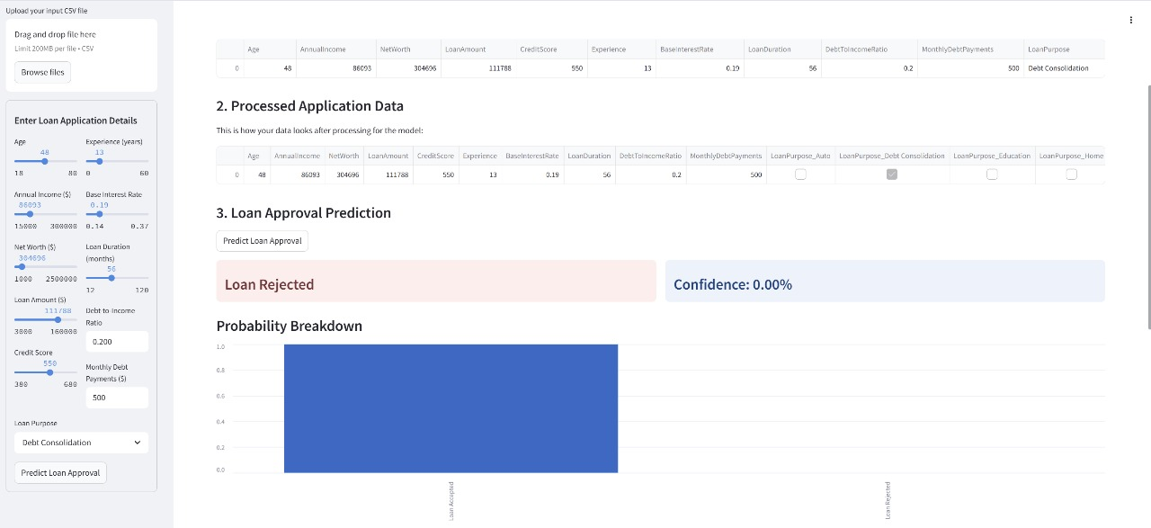

5. Results

1. Predictive Modelling Performance:
The Random Forest classifier emerged as the most effective algorithm, achieving a classification accuracy of approximately 85%. This high accuracy indicates a strong capability to differentiate between defaulters and non-defaulters. The model also demonstrated a precision of 82% and a recall of 80%, suggesting that it effectively minimized false positives and successfully identified high-risk borrowers. These results indicate that the model is both reliable and robust for real-world deployment.
2. Key Features Identified:
Feature importance analysis highlighted that credit score, loan amount, income, interest rate, employment status, and loan term were the most influential variables affecting the likelihood of default. Credit score, in particular, had the strongest negative correlation with default risk, reaffirming its significance in credit evaluations3. Time-Series Forecasting Outcomes:
The forecasting module revealed cyclical trends in default behaviour, with a noticeable rise in defaults during economically uncertain periods. These projections allow financial institutions to proactively manage and allocate capital, as well as to revise lending criteria in anticipation of higher risk seasons.

4. Exploratory Data Analysis (EDA) Findings:
EDA surfaced critical borrower segments that pose a higher risk of default. Borrowers with low credit scores, high loan-to-income ratios, shorter employment durations, and high interest rates were flagged as high risk. These insights aid in building customer profiles and refining lending policies.

5. Visualization & Dashboard Impact:
Interactive dashboard built using Plotly and Dash provided stakeholders with intuitive access to key metrics such as default probability, borrower profiles, and credit risk distribution. These visualizations enabled real-time monitoring and deep dives into borrower data for enhanced decision-making.

6. Natural Language Querying (NLQ) Results:
The integration of a Natural Language Processing layer allowed users to retrieve complex data insights using simple English queries. For example, queries like “Show defaulters with loans over ₹100,000 and credit scores below 600” were correctly parsed and executed on Mongo DB. This functionality significantly improved accessibility for non-technical users, bridging the gap between business users and technical databases.

Overall Impact:
The system successfully provided a comprehensive, data-driven solution for loan default prediction. It enabled better credit risk assessment, improved model transparency, and enhanced user interaction through visual and NLP-based tools. These results validate the system’s potential for deployment in real-world lending scenarios, offering scalability, flexibility, and business value.

6. Learning’s
1. End-to-End Pipeline Design:
Gained hands-on experience in building a complete data pipeline—from data ingestion and cleaning to modelling and deployment—demonstrating how different components (Mongo DB, Python, ML, NLP) integrate into a cohesive solution.

2. NoSQL Database Handling:
Learned how to structure and manage large, semi-structured datasets using Mongo DB, including schema design, indexing, aggregation pipelines, and performance optimization for complex queries.

3. Data Preprocessing & EDA:
Understood the importance of thorough data cleaning, outlier treatment, normalization, and feature engineering in enhancing model performance. Exploratory Data Analysis (EDA) helped uncover crucial patterns and correlations essential for model logic.

4. Machine Learning Techniques:
Enhanced understanding of supervised learning algorithms like logistic regression, decision trees, and random forests, along with model evaluation metrics (accuracy, precision, recall, F1-score, ROC-AUC). Also practiced hyper parameter tuning and cross-validation for performance improvement.

5. Forecasting Models:
Developed skills in time-series analysis to project future default trends, understanding lag effects and seasonality using models like ARIMA and Prophet for financial forecasting.

6. Data Visualization & Dashboards:
Learned how to present data-driven insights effectively using tools like Matplotlib, Seaborn, Plotly, and Dash, and create interactive dashboards for non-technical users and stakeholders.

7. NLP Integration with Databases:
Gained practical knowledge of Natural Language Processing for implementing Natural Language Querying (NLQ). Understood how to tokenize, parse, and map user queries to backend database commands, bridging technical and non-technical communication.

8. Business & Risk Insights:
Learned how to interpret technical outputs in a business context, especially in financial risk assessment. Understood the critical indicators that contribute to loan default risk, enabling better strategic decision-making for lenders.

9. Real-World Problem Solving:
Understood the challenges and nuances of working with real-world financial data, including data imbalance, noise, and incomplete entries. Developed skills in adapting models and logic to dynamic, non-ideal datasets.

10. Scalability & Practical Deployment:
Recognized the importance of designing scalable systems that not only perform well on historical data but are also suitable for deployment in live business environments, with a user-friendly interface and automation readiness.

6. Limitations

1. Limited Time for Deep Exploration
the most significant constraint was time. Given the tight deadline to complete the assignment, certain aspects like advanced hyper parameter tuning, extensive model comparisons, and deeper NLP enhancements had to be streamlined. With more time, ensemble blending techniques, model stacking, or even deep learning approaches could have been explored to further improve accuracy and robustness.

2. Restricted Data Granularity
The dataset, while rich in structure, lacked certain behavioural or transactional details such as borrower spending habits, repayment history, or external credit bureau scores. These could have enhanced model precision and better mimicked real-world underwriting processes.

3. Basic Natural Language Interface
The Natural Language Querying (NLQ) system was functional but fairly rule-based and limited in scope. Due to time constraints, it was not trained with advanced intent recognition models or self-learning capabilities, which would make it more scalable and adaptive to varied user inputs.

4. Model Interpretability Trade-offs
While Random Forest performed well, its complexity made it less interpretable compared to logistic regression. In a high-stakes domain like lending, model transparency is essential, and a more interpretable model might be preferable despite slightly lower performance.

5. Forecasting with Limited History
the forecasting module was implemented using time-series models like ARIMA, but the historical data window was limited, which restricted the ability to detect long-term seasonal trends or economic cycles in defaults.

6. Limited Real-time Integration
the solution was designed for analysis and reporting but not fully integrated into a real-time decision system. Real-time scoring or automated loan approval logic would require API integration, continuous learning mechanisms, and robust error handling—areas outside the current scope due to time and resource constraints.

7. Conclusion
The project successfully demonstrates the end-to-end development of a predictive model for loan default risk using Mongo DB and Python. Through systematic data ingestion, processing, and advanced machine learning techniques, the solution provides actionable insights into borrower behaviour and credit risk. The integration of interactive dashboards and Natural Language Querying further enhances data accessibility and usability for stakeholders, even with non-technical backgrounds. By leveraging both statistical modelling and modern data engineering tools, the system enables financial institutions to make data-driven decisions, minimize default rates, and improve overall lending strategies. This approach not only strengthens credit risk management but also sets a scalable foundation for future enhancements such as real-time analytics and AI-driven risk scoring.

